(Carole King)
When you're and troubled
And you need some loving
And nothing, nothing is going right …
Close your 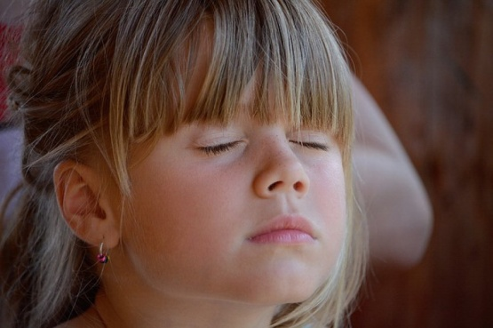 and think of me
And soon I will be there
To brighten up even your darkest 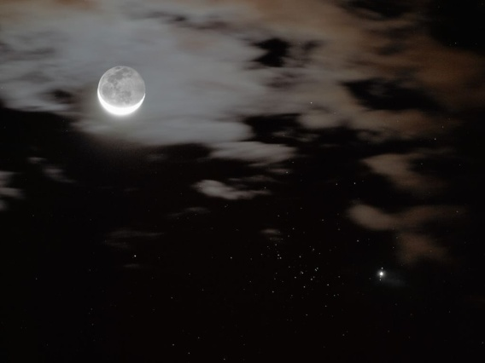
You just
my name
And you know wherever I am

I'll come to see you again

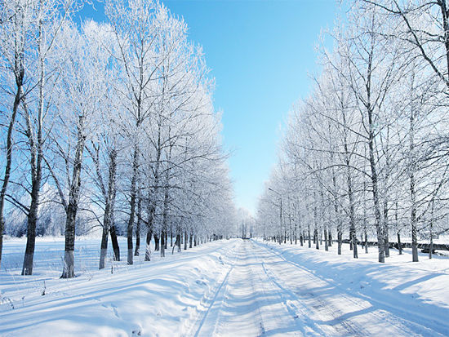
or

All you have to do is
And I'll be there
You've got a

If the sky above you
Grows 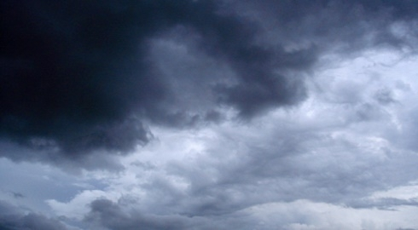 and full of clouds
And that old north begins to blow
Keep your head together
And call my name out loud
Soon you'll hear me at your door
You just
my name
And you know wherever I am

I'll come to see you again

Winter, spring, summer or fall
All you have to do is call
And I’ll be there
Yes, I will

Now ain't it good to know
that you've got a
When 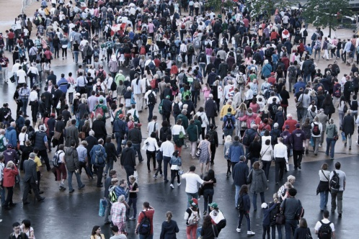 can be so cold
They'll you and desert you
And your soul if you let them
Oh, but don't you let them

You just call out my name
And you know wherever I am
I’ll come running to see you again
Winter, spring, summer or fall
All you have to do is call
And I’ll be there
You’ve got a friend

